GLEDALIŠKE DELAVNICE Z NARAVNIM GOVORCEM ANGLEŠČINE

V novembru bo prišel k nam Tony Cealy, po rodu Jamajčan, ki živi v Londonu, in izvaja gledališke delavnice v različnih državah po svetu . Pri svojem delu uporablja metode in tehnike Gledališča zatiranih (Theatre of the Oppressed).
Izvajal bo delavnice na osnovnih šolah v Slov. Konjicah, Ločah, Zrečah in Vitanju.

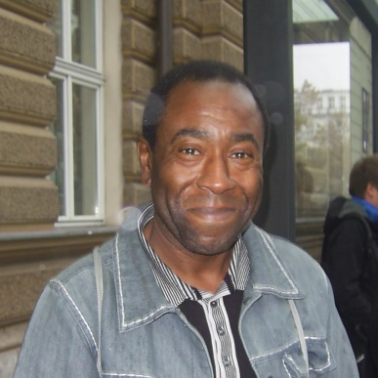
Kaj pravi Tony o sebi?

I'm an actor, trainer, drama facilitator and theatre practitioner.

In planning and delivering my work I use a mixture of short highly focused creative-action-methods and drama techniques to dynamize people's thoughts, feelings and concerns around the issues that come up for them throughout the workshop process.

I use drama activities that develop and build people’s confidence and self esteem, sharpen thinking and communication skills and develop the person, influencing their physical, emotional and spiritual well-being and their perspective of the world. As well as being challenging and fun the process allows participants to review and re evaluate their critical thinking.

Več o njegovem delu si lahko pogledate na naslednji povezavi: http://www.tonycealy.com/workshops/

V nedeljo, 15. 11. 2015, bo imel na OŠ Pod goro delavnico za mešano skupino (starost 15 +).

Tema: NASILJE (odkrivanje, preprečevanje, …)

CENA: 10 EVROV

Delavnica bo potekala od 9.00 do 13. ure. Vmes bo 15-minutni odmor.

_____________________________________________________________________________________

PRIJAVNICA

____________________________________ , (dijak-inja / študent-ka / drugo), se prijavljam na delavnico
/ime, priimek/ /obkroži/

Tony-ja Cealy-ja v nedeljo, 15. 11. 2015, na OŠ Pod goro Slov. Konjice.

Datum: _____________________________ Podpis : _________________________

